Accessing STATs

* Click Link (Save this link in your favorites for future use.) <http://stats.gmfapps.gmfinancial.com/home.aspx>
* Enter your NA username and password. (The same credentials you use to sign into the GMF Portal or Kronos.) *PLEASE REMEMBER TO ENTER AMERICREDIT*\*YourUsername AS SHOWN BELOW*

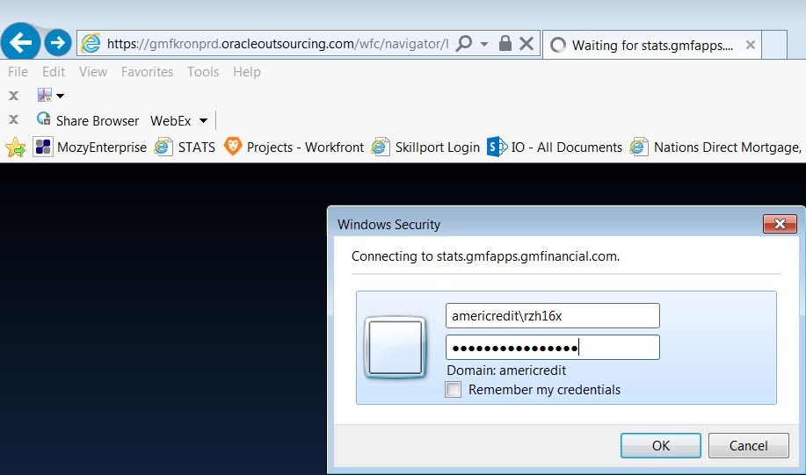

* Once you sign in, you should now see the STATs page with policies you need to acknowledge.

